Professional Skills Period 4
Professional Skills Period 4 1B
Personal Development Plan

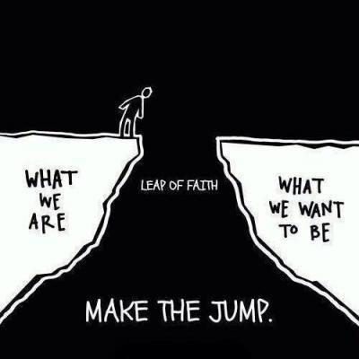
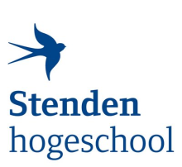

Regarding: Personal development plan #1
Student name: Corodeanu David Cristian
Student number: 5448980
Course: Professional Skills
Phase: Year 1
Study coach Miguel Ranchor

- What competences will I develop during this period?

Professional workmanship
Profession-specific competencies | What requires special attention?
- Managing | During this period, I will further develop my management skills.
- Analysing | During this period, I will practice analysing professional products.
- Advising | During this period, I will try to keep giving good advice to my team members.
- Designing | During this period, I will further develop my designing skills.
- Executing | During this period, I will make sure to execute the task needed in the timeframe given and make sure it’s up to the quality standards.

Professionalisation
Study career competences | What requires special attention?
- Ability to pursue one’s own competence development independently | I will make sure to pursue my professional goals and learn how to study independently more efficient.
- Ability to take responsibility for one's own study progress | I already take responsibility for my own study progress and make the necessary adjustments if needed.
- Ability to make the right study and career choices | I know that I made the right choice to come study at this university and I will follow this path.
- Ability to build up a supportive social network | I constantly work on improving my social skills and making new friends and expand my social network.

Professionalisation
Study competencies | What requires special attention?
- To learn how to learn | I am still learning to apply the learning techniques given in the Professional Skills lessons and I’m always trying to make my learning process more efficient.
- Planning | I will further put in practice my planning skills and learn from them.
- Time management | I will further optimize my time and make sure everything I do is as efficient as possible.
- Project-based working | I will work in a project with other people this period and this will help me further develop my project-based working skills.

Social and communicative competencies
Social and communicative competences | What requires special attention?
- Ability to correct in an appropriate way | I think I have the capability to correct in an appropriate way and make sure the people around me don’t get offended.
- Interview techniques | I will do more research on interview techniques this period and learn how to properly behave in an interview scenario.
- Personal feedback | During this period, I will learn how to give and receive 360 feedback.
- Presentation skills | During this period, I will learn and practice my presentation skills both in front of my team members and the lecturers.
- Reporting in writing | During this period, I will learn how to properly write a report.
- Techniques in meeting | During this period, I will further learn and practice how to write an Agenda for a meeting that I will conduct. I will also practice writing minutes of meeting and taking notes.
- Writing a formal or business letter | I will further improve my skills in writing formal and business letters.

2. What are my personal development goals?
Action plan: which activities will I undertake to realise my developmental goals?
Development goal  (SMART) | Activity  (SMART) | Measurable result  (SMART) | Time completed
1. Learn the basic Dutch (up to A1 level) language in order to be able to communicate with the locals and adapt to the Dutch society. Also, this will improve my employment opportunities. | Attend each week the normal Dutch lessons for one hour and a half and also the advanced Dutch lessons for three hours. In addition to these I will complete all the weekly assignments given and complete all the exercises for the chapters taught in that week. Also, each day I will spend 10-15 minutes on Duolingo to do Dutch lessons. | Earn an official A1 Dutch language diploma as proof of language proficiency. In case I do not receive the diploma until 11-06-2025 I will post proof on my attendance to the extra Dutch classes, my Duolingo day streak and Analytics, and pictures of the assignments made from the A1 Dutch book and website. | 11-06-2025
2. Learn how to cook and maintain a good and healthy diet in order to have a good physical health which helps improve my mental health and productivity and save money on food. | Cook twice a week and have at least 6 days cooked food for both me and my friend. The food will consist in both a soup and a main dish. Also cook at least 2 new dishes every 2 weeks so I expand my culinary repertoire and eat diversly. | A word document with the names of the dishes and the recipes that I followed and pictures of the cooking process and the final product, and each dish will be tasted by my friend to ensure a good quality and taste have been achieved. | 11-06-2025
3. Develop my social awareness and teamwork skills by collaborating with people from diverse backgrounds to create a digital storytelling platform. This will improve my communication, empathy, and project collaboration abilities. | Enrol and actively participate in the MDT project. Participate at meetings with a group of people who face challenges in their daily life. After getting to know them and their challenges together with the team we will produce a creative storytelling product to inform ‘the world’ about their personal stories. Thus, creating more understanding for what these Invisible Heroes are facing in their daily lives.  I will participate in group meetings and brainstorming sessions and work on building a website on which people can tell their stories. The workload will be 80 hours, which will be spread over 4 weeks. | An official national MDT certificate of participation. In case I do not receive the certificate until 11-06-2025 I will send a link with the website made for the project to showcase the work that I have done. | 11-06-2025

For approval study coach:

For approval student:

